**Business Requirement Document(Snowflake Testing): Medico Pvt. Ltd.**



**Medico Private limited**

**February 2022**

**1. Testing**

**1.1.Testing Snowflake Tables**

The following screenshots show the test scripts for whether the tables loaded into snowflake are having the exact data from the source taken with respect to number of rows & columns etc.,

Testing number of rows and columns of following tables: FEEDBACK, CAMPAIGN, APEX TEST RESULT, ACCOUNT HISTORY

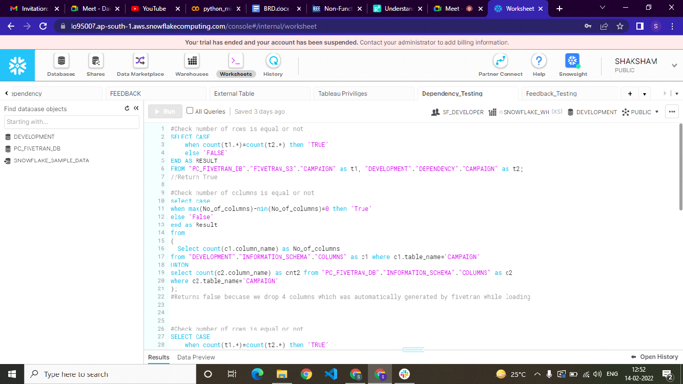

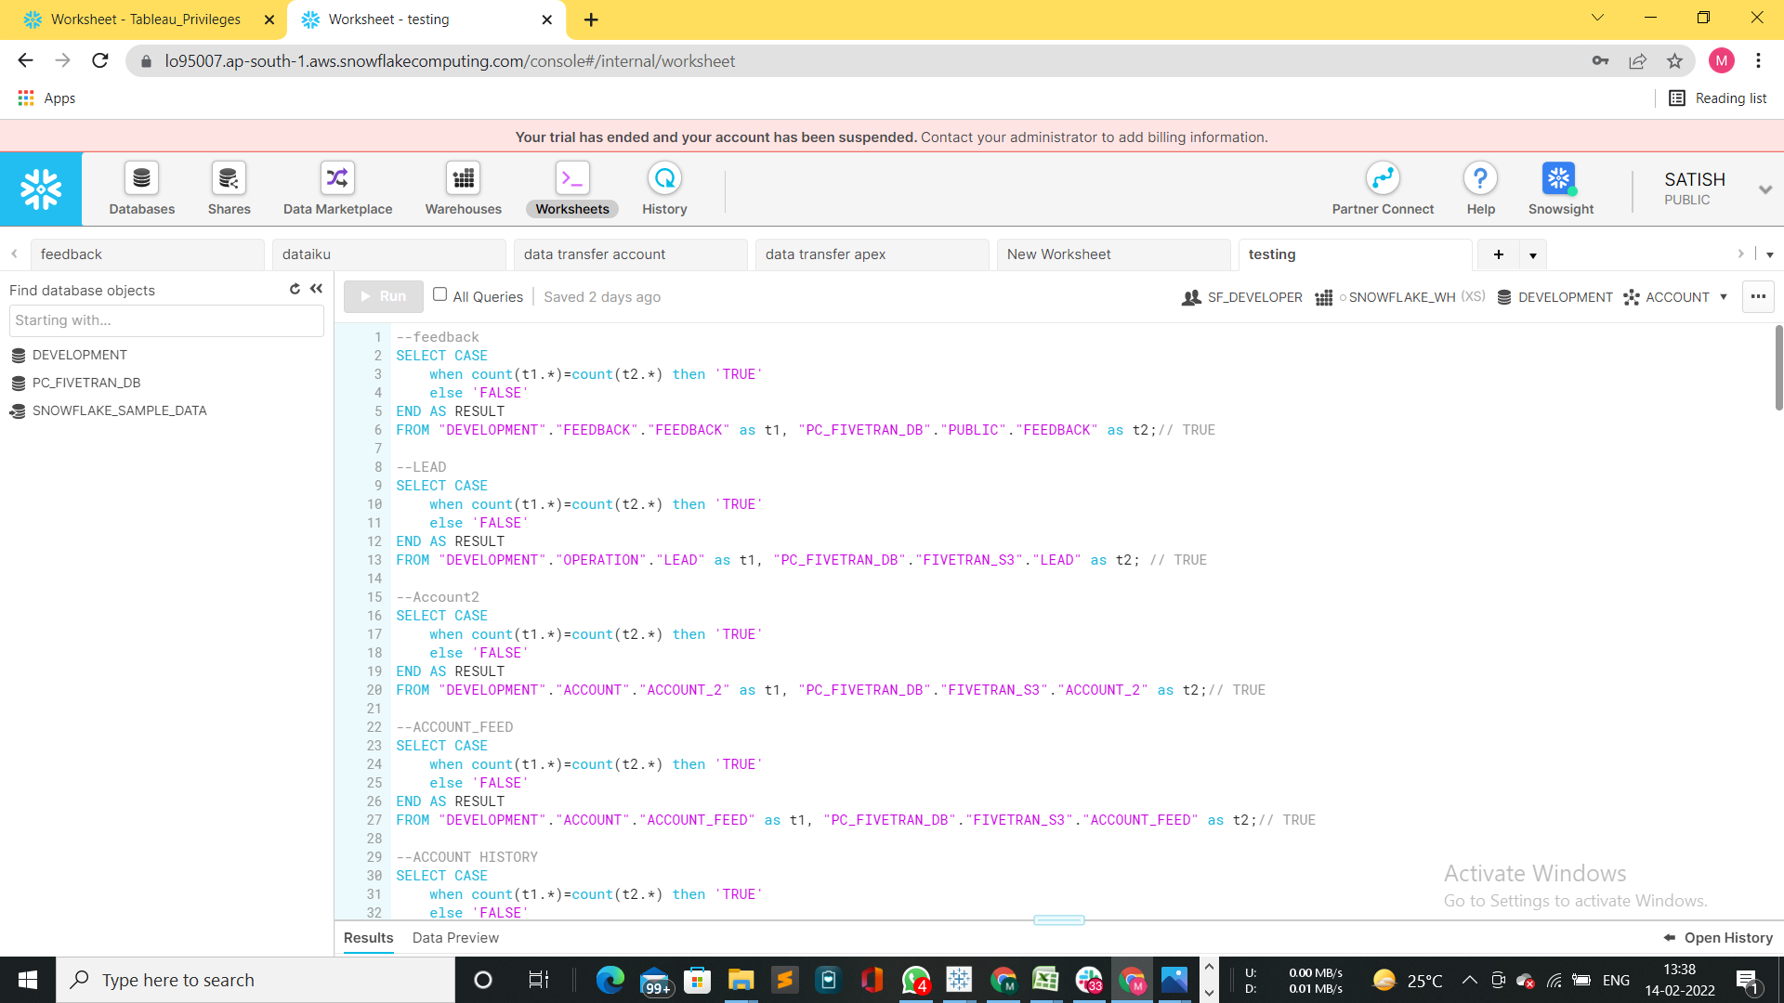

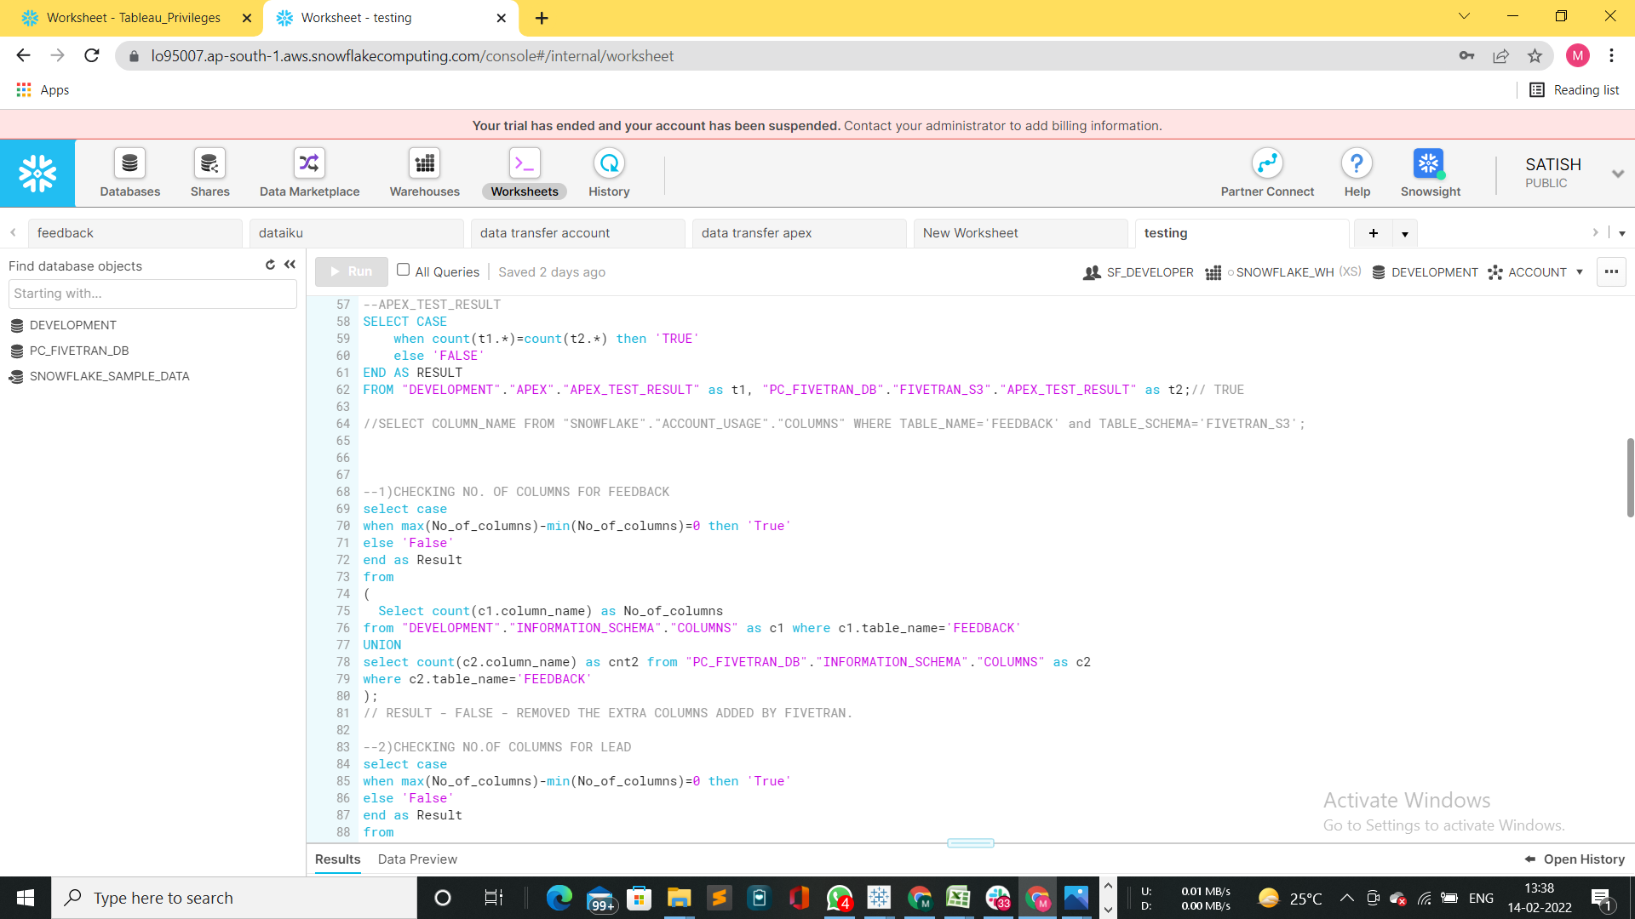

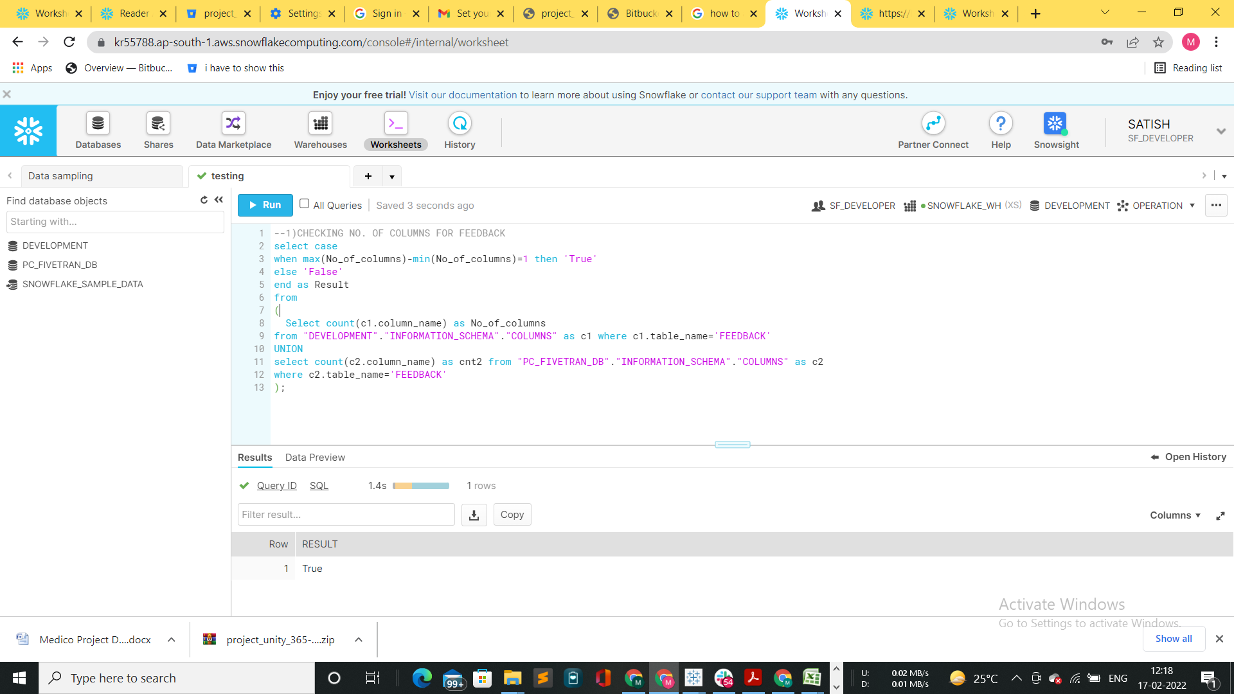

**1.2. Testing Snowpipe**

* Once the file is arrived in the S3 bucket connected to Snowpipe it gets loaded to snowflake.

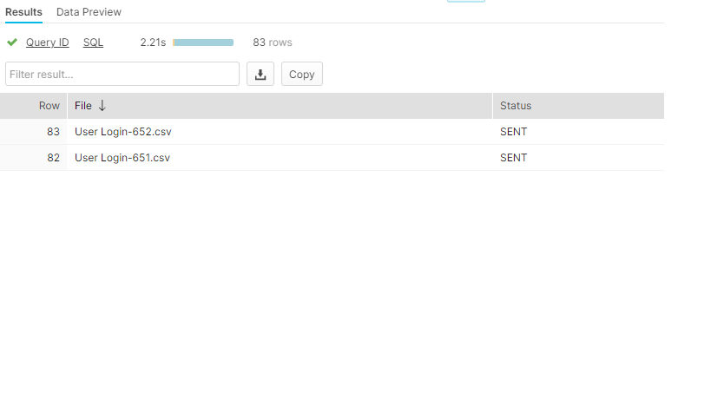

* Data loaded to user login table in Data lake

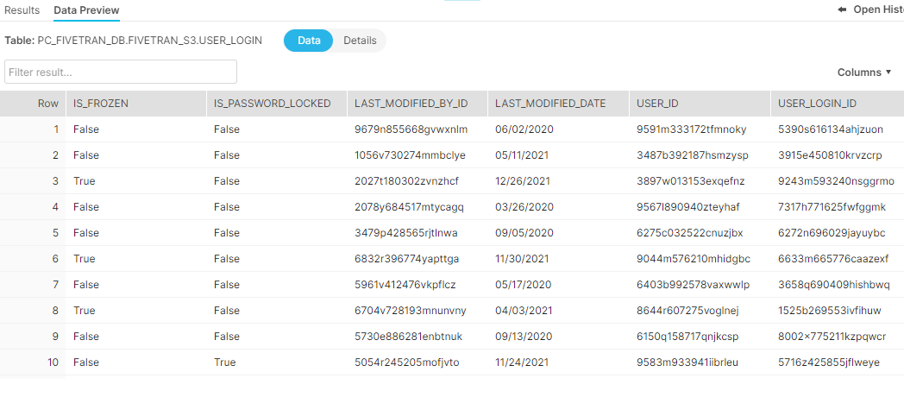

* Pipe status

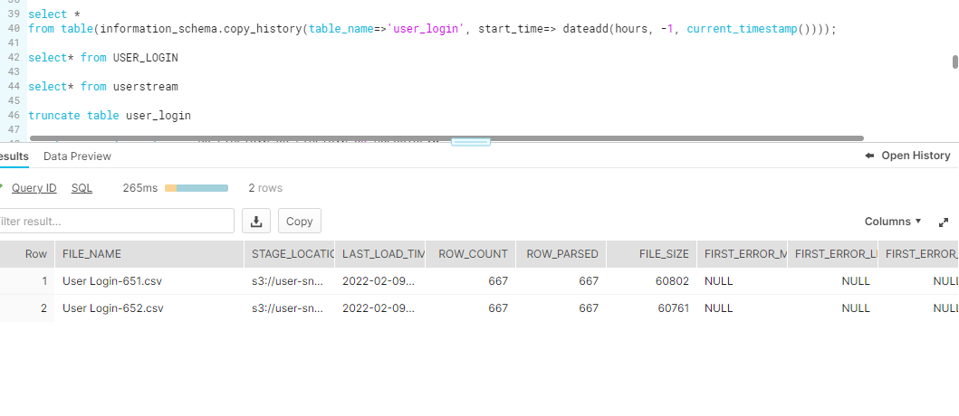

* Task status

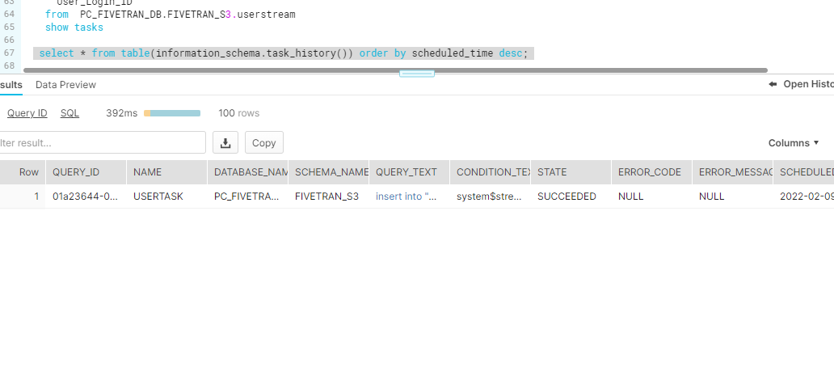

* Data in user login table in Data warehouse after task has inserted by fetching important columns from stream

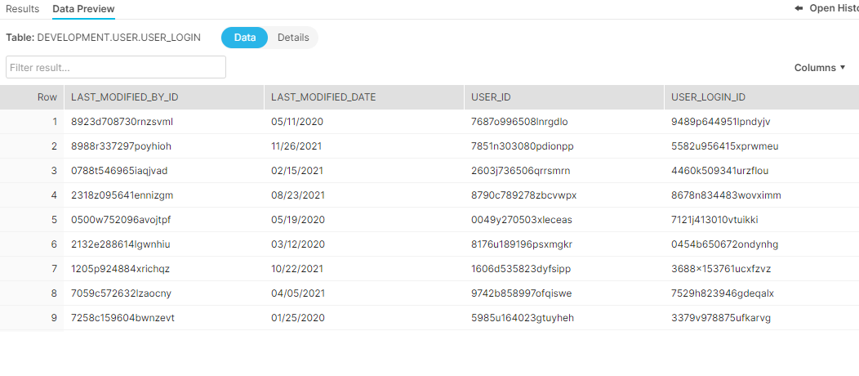

**1.3. Test Case Tables**

The following is the test case table for the same:

| **TEST CASE ID** | **TEST CASE NAME** | **TEST CASE DESCRIPTION** | **RESULT** |
| --- | --- | --- | --- |
| TO1 | SNOWPIPE | TEST CASE TO CHECK IF THE DATA LOADED IN SNOWFLAKE IS CORRECT | PASS |
| TO2 | TESTING OF LOADED DATA TABLES | VISUAL FOR ACCESS METRICS | PASS |
| TO3 | TESTING OF LOADED DATA TABLES | CAMPAIGN | PASS |
| TO4 | TESTING OF LOADED DATA TABLES | FEEDBACK | PASS |
| TO5 | TESTING OF LOADED DATA TABLES | ZONE | PASS |
| TO6 | TESTING OF LOADED DATA TABLES | ACCOUNT_HISTORY | PASS |
| TO7 | TESTING OF LOADED DATA TABLES | ACCOUNT_2 | PASS |
| TO8 | TESTING OF LOADED DATA TABLES | ACCOUNT_FEED | PASS |
| TO9 | TESTING OF LOADED DATA TABLES | ACCOUNT_SHARE | PASS |
| TO10 | TESTING OF LOADED DATA TABLES | APEX_PAGE | PASS |
| TO11 | TESTING OF LOADED DATA TABLES | ASYNCAPEXJOB | PASS |
| TO12 | TESTING OF LOADED DATA TABLES | APEX_TEST_RESULT | PASS |
| TO12 | TESTING OF LOADED DATA TABLES | APEX_PAGE_INFO | PASS |
| TO13 | Validating JSON data | SALARY | PASS |
| TO14 | Validating JSON data | JOB | PASS |